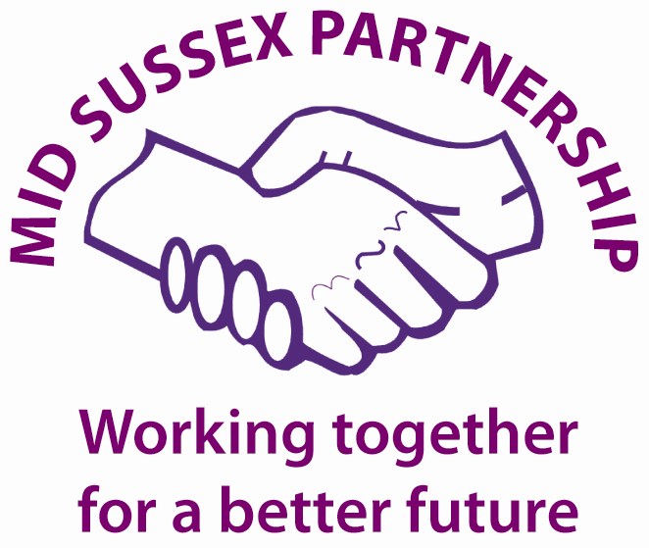

Mid Sussex Partnership Board meeting, 20th October 2022

Key Decisions
It was agreed that:
No Key Decisions were made at this meeting.

Welcome and introductions
Attendees:
Cllr Jonathan Ash-Edwards | Leader of MSDC - Chair
Rebecca Hair | Commissioning and Partnerships Advisor, MSDC – Minute Taker
Ben Friar | Haywards Heath College
Emily King | WSCC
Gordon Ackroyd | Acting CEO, Mid Sussex Voluntary Action (MSVA)
Matt Roberts | Community Transport Sussex (CTS)
Cllr Norman Webster | Cabinet Member for Community at MSDC
Paul Turner | Community Services Manager, MSDC
Anthony Bentham | Sergeant, Sussex Police
Dawn Rennie | Clarion HG
Grace Towner | Administration Support Assistant, Health and Wellbeing, MSDC
Jason Mather | Head of Client Services, CA in West Sussex
Amy Galea | Executive Director for Primary Care Commissioning
Pennie Ford | Executive Managing Director, West Sussex NHS Sussex
Debra Balfour | Head of Collaborative Working (West Sussex) NHS
Garry Money | Director of Primary Care Operations, NHS

Apologies:
Daniel MacIntyre | WS Public Health
Darren Taylor | Inspector, Sussex Police
Gary Waters | Fire and Rescue Service, WSCC
Cllr Jacquie Russell | Cabinet Member for Children and Families, WSCC
Mandy Cunningham | Community Safety & Safeguarding Manager, MSDC
Nick Dias | Chief Inspector, Sussex Police
Nicky Dodds | Clarion HG
Paul Riley | Haywards Heath College

2. Minutes of the MSP Board Meeting 4th August 2022
The minutes were deemed a true and accurate record of the meeting and were agreed.

3. Round table introductions and hot topics
No-one raised any hot topics prior to the main agenda presentations.

4. Citizens Advice – Cost of Living
Jason Mather (JM) Head of Client Services, CA in West Sussex, gave a presentation. The presentation is Appendix One to these Minutes.

PT asked how they are coping with 2.5 FTE debt advisors for West Sussex. JM confirmed that have 2.5 FTE debt advisors that are funded by Money Advice and Pensions Service, and they have access to other debt services. They also have homelessness prevention advisor in Horsham and Crawley. They have linked up with the Trussell Trust this week to have a paid member of staff on CA sites.

PT requested to talk to JM about the Household Support Fund outside of this meeting.

6. NHS - Current primary care services and the pressures that they are currently facing post pandemic and in the light of the growing cost of living crisis.
Amy Galea, Executive Director for Primary Care Commissioning Chief primary care officer for Sussex spoke a verbal update. AG is responsible for: GP commissioning; Community Pharmacy, dentistry and optometrist commissioning; Covid and ‘flu vaccinations.

The NHS offer priority access to primary care services. The number of appointments available is now the same as delivered before pandemic, but there has been a change in mode of delivering these appointments, with more digital and phone consults offered. Sussex wide there are 750,000 appointments seen in General Practices and in West Sussex this is above national average.

There is a Winter Fund of £1.5 million to change how appointments are made and seen. They are researching people’s preferences on how people want to be seen. There are fewer GPs than five years ago however they are increasing the number of specialist services and appointments i.e., physio, mental health practitioner etc. They are seeing more complex presentations, so sometimes it is better to see a specialist however some people don’t see it that way and want to see a doctor.

When the CCG existed, GPs used to be part of the teams that were responsible for being a service for a trust, this no longer happens. The NHS Trust is now run by a different group of people. The GPs responsibility is to design and address clinical issues as opposed to buy in services. There is low morale amongst the NHS currently. There are issues with the NHS dentistry services, which are run by a national contract. They are working to try to understand what issues are not related to the national contract that they may resolve.

PT – The MSDC Health and Wellbeing service is funded via Public Health. Social prescribers have increased referrals into services. We are currently trying to commission a County wide falls prevention service and wondered who the best contact is. Contact Pennie Ford, or Nicky Stempt, Aging Well team.

MR – CTS are assisting people getting to places for vaccines as people are having difficulty in getting to appointments. How much does a “did not attend appointment” cost the NHS? PF replied They are going to address these and will use lessons learnt during the pandemic and see what we can do differently now we are an ICS.

Cllr NW – completely agrees that seeing a GP might not be the right person and there is a challenge is addressing this. We are ready to help with sending out this message. Community hubs and venues can be used to be linked in and make partnerships stronger.

5. NHS Restructure - The new Integrated Care System for Sussex and what that means for Mid Sussex residents.
Pennie Ford, Executive Managing Director, West Sussex NHS Sussex, gave a presentation. The presentation is Appendix Two to these Minutes.

The structure of the NHS changed on 1st July, when they changed from the CCG to the Integrated Care System (ICS). It is a good to continue to engage with the NHS partnership on a strategic level and to have insight on what they propose to do in the future. Pennie was able to give an explanation on some of their priorities in terms of health and the key priorities they’re focusing on and the data they use to get some of that information. It would be great for us to mutually share timely data.

PT – It is helpful that they have shaped the LCN to match and reflect the D&B boundaries. It is great now that the LCN is in place, and this is improving relationships with the NHS and all parties are attending partnership meetings. It was also great that at the diabetes screening event that took place earlier this year, individuals felt listened to and considered that to be a good enough contact to not need or want an appointment with a GP.

Action: Cllr A-E asked for Pennie and Debra to consider and nominate some one to represent the ICS, NHS and sit on the MSP Board.

7. UK Shared Prosperity Fund – Project update
Rebecca Hair (RH) updated. The MSDC Investment Plan has been submitted to the UK Shared Prosperity Fund. The bid has been received. The Department for Levelling Up, Housing, and Communities have asked for some clarification questions regarding some of the figures and these have been confirmed. We are awaiting the outcome of the bid.

8. Question time in respect of the Health Subgroup Quarter 2 Report
Paul Turner (PT) updated. A Health Subgroup Q2 Report highlighting the work of this subgroup was previously circulated to members of the MSP Board. The Health Subgroup is also the Local Community Network (LCN). The Health Subgroup priorities were set out at the last meeting in June. The cost of living was a concern at the June meeting, and they organised another subgroup meeting with key partners from Healthwatch, Public Health, Citizens Advice to attend in August. Some of the key issues that have come up and were discussed included: transport; volunteering; and affordable warmth. The Wellbeing team have updated the Community Connections directory that is services for older people in the district and is very popular with health professionals. They have also created a Winter Support Guide and have over 1,500 requests for this publication already. It is going to print next week, and it will also be in the MSDC Mid Sussex Matters magazine.

9. Question time in respect of the Community Safety Subgroup Quarter 2 Report
Rebecca Hair (RH) updated. A Community Safety Subgroup Q2 Report highlighting the work of this subgroup was previously circulated to members of the MSP Board. Some projects that ran in Q1, continued to run in Q2 including the Purple Bus at East Grinstead, where they have had 363 contacts with young people during June – August 2022. It is confirmed that the Mid Sussex Community Safety Partnership will be receiving £10,000 from the Safer Streets Fund. Funding was requested earlier in the year to purchase two re-deployable CCTV cameras to be used in ASB hotspots. The location of the cameras will be determined and agreed by the Community Safety Subgroup and reviewed quarterly. Work is currently underway to draw up an appropriate policy and procedure in line with data protection regulations.

10. Question time in respect of the Community Resilience Subgroup Quarter 2 Report
Gordon Ackroyd (GA) updated. A Community Resilience Subgroup Q2 Report highlighting the work of this subgroup was previously circulated to members of the MSP Board. The CRS are aware that there is a big decrease in people stepping forward to volunteer post pandemic, which is a pattern repeated regionally and the CRS will be looking to see how to increase and encourage volunteering. GA was please that when Steven Lightfoot from the NHS visited the CTC that there were several activities taking place including: Podiatry, Social prescriber, chair-obics, and yoga.
MR – There is currently a Travel Buddies pilot in Crawley, and they are looking to expand into Mid Sussex, which could in turn lead to befriending opportunities. The Travel Buddies scheme can be assisting walking someone to the shops and not using minibuses.

EK – Informed the group that libraries will sign up to the Warm Places scheme, but they will not advertise the scheme in an extrovert way as they wish to keep the integrity of a library service.

11. Mid Sussex NEETs Procurement
Rebecca Hair (RH) Updated. The return deadline for the Mid Sussex NEETs tender was 12pm on Friday 7th October. The evaluation period runs from 10th October until 4th November. The submitted tenders have been assessed, and moderated. On Monday 7th November we will Issue Notification to Award Contract Decision. We will then have a voluntary ten-day standstill period and the Final Award will be made on Friday 18th November 2022. There is then a month for us and the appointed bidder to execute the contract, with the contract starting on 3rd January 2023
12. MSP Projects and Budget for 2022-23
Rebecca Hair (RH) updated. The only spend that has taken place in Q2 is that which is received from Sussex PCC that is allocated to our Community Project Officer (Young People) post.
Projects that took place in Q2 were paid for in Q1.
It is confirmed that the Mid Sussex Community Safety Partnership will be receiving £10,000 from the Safer Streets Fund. Funding was requested earlier in the year to purchase two re-deployable CCTV cameras to be used in ASB hotspots.
There are no current financial decisions to be agreed by the board at this current meeting.

13. Emerging issues and future topics for Board and dates for future meetings:
PT proposed that the soon to be appointed service provider for NEETs could be invited to present at the January MSP Board meeting to discuss how they intend to deliver the contract.

PT mentioned that the latest SIA data from WSCC should be available by the end of the calendar year and that it may be a good idea to discuss this at the January MSP Board meeting.

It was agreed that all MSP Board members should consider emerging issues and future topics for the next MSP Board meeting.

The next MSPB meetings are scheduled for:
- Thursday 12th January 2023.
- Thursday 27th April 2023.
These are all currently scheduled to be online meetings.

